Brain Tumor Detection From MRI

**For the course of**

Electronics and Communication Engineering

**Submitted By**

**Sourav Paul (Roll-24400317010)**

**Sourav Roy (Roll-24400317009)**

**Anushka Dey (Roll-24400317047)**

**Surya Das (Roll-24400317006)**

**Guided By**

**Prof. Roshni Chakraborty**

**Submitted To**

**Techno Engineering College Banipur**

**For Academic year**

**2020-2021**

## **ABSTRACT**:

The main objective of this Project is to build an Application that is capable of “*detecting and determining*” a brain tumour using Image Processing in MATLAB**.** The most vital part is template design and the formation of algorithm of brain tumour detection.

Some of the key features used in this project are - *Image Acquisition*, *Noise Reduction, Image Resizing, Tumour Region Identification, Marking of Tumour,* etc. A **Graphical User Interface** (GUI) is also used to build a better interface for the user. It allows us to understand the algorithm's true potential and how it can be further developed due time.

After an image is provided to the algorithm it processes the image and informs the user how harmful the tumour is to the patient, and what necessary steps should he/she take to find a cure for it. A very minute but key feature is added that informs the user how accurate the detection is, which is very handy while dealing with such a disease.

* **Contents**

❖ **ABSTRACT**: 2

**** **INTRODUCTION**: 4

**** **METHODOLOGY**: 5

➢ **Block Diagram Of Methodology**: 5

➢ **Image Acquisition** 5

➢ **Reduction Of Noise**: 5

➢ **Image Resizing** 6

➢ **Binary Conversion** 6

➢ **Tumor Region Identification** 6

➢ **Marking of Tumor** 6

➢ **Classification** 6

1. **Feature Extraction** 6

2. **Feature Reduction using PCA** 7

*3.* **Support Vector Machine** 7

➢ **GUI Design** 8

**** **SIMULATION & RESULTS**: 9

➢ **GUI**………………………………………………………………………………………………………………………………………9

➢ **Internal Process Outputs** 10

➢ **Experimental Results**: 11

**** **CONCLUSION**: 12

**** **References**: 13

**** **Acknowledgment**: 15

# **INTRODUCTION**:

The smallest important basic part of all living entities is cell. Human body comprises around millions of cells. Every cell has its individual characteristics and function. These cells split to form additional cells in a well-behaved way for proper functioning of body. When cells split and nurture wildly to form fresh cells, but its outcomes in a bulk of surplus tissue which is well-defined as a tumor. Brain tumor occurs as a mass abnormal cells replicating in an uncontrolled manner. It affects the growth and function of normal cells in brain and occupies the space in brain. It causes interruption of brain cell function and cause damage to life.

There are mainly Two Types of Brain Tumor as stated below:-

1.Benign Brain Tumor (Non-Cancerous)

2.Malignant Brain Tumor (Cancerous)

**1.Benign Brain Tumor:** A **Benign Brain Tumor** is a mass of cells that grows relatively slowly in the brain.These types of brain tumors tend to stay in one place and do not spread.Benign Tumor can be removed ,and they rarely grow back.

**2.Malignant Brain Tumor:** A **Malignant Brain Tumor** is a fast-growing cancer that spreads to other areas of the brain and spine.Most Malignant tumors are secondary cancers,which means they started in another part of the body and spread to the brain. Primary brain tumors are those that started in the brain.

MRI images show the brain structures, tumor’s size and location. From the MRI images, the information such as tumor’s location provided radiologists an easy way to diagnose the tumor and planted a surgical approach for its removal. The diagnosis of Brain Tumors in MRI images requires radiologist’s knowledge and experience. In order to overcome the difficulties in evaluating the Brain Tumor,an automated detection method for Brain Tumor using MRI images is proposed.

# **METHODOLOGY**:

In this project, the most vital part is template design and the formation of the algorithm for brain tumor detection. Before designing, the process of understanding the location of brain tumor and characteristics of MRI image the summary of methodology is in this following block diagram.

## **Block Diagram Of Methodology**:

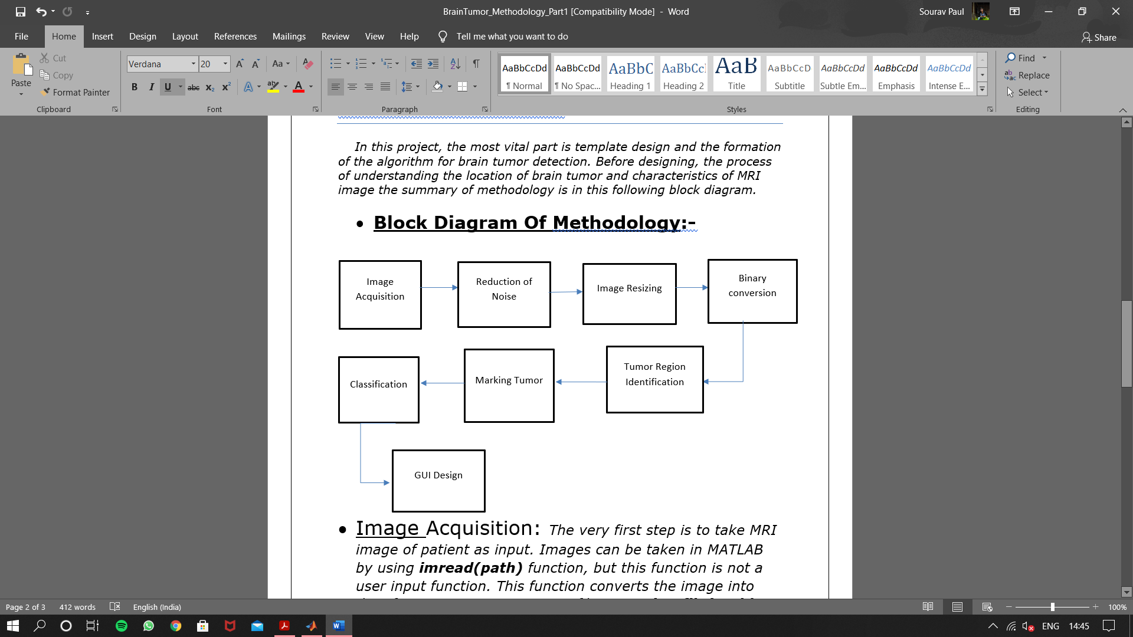

* **Image Acquisition**:The very first step is to take MRI image of patient as input. Images can be taken in MATLAB by using imread(path) function, but this function is not a user input function. This function converts the image into data format. To get image as a file input uigetfile(path) is used. This function can be used as a user input function.
* **Reduction Of Noise**:For reduction of noise masking and anisotropic diffusion technique was used. This technique reduces the noise without removing significant parts of the image content , lines, typical edges or any other details. For masking some extra pixels were added to the image of the same colour as the object.
* **Image Resizing**:When image acquired in MATLAB, its initial size is 256*256 with unit8 class. Variables in MATLAB of data type(class) **unit8** are stored as 1-byte(8-bit) unsigned integers. In this project, the unit8 is used to convert an image file into matrix format.
* **Binary Conversion**:The segmentation of an image into a binary image used to differentiate the background from the desired object. For binary conversion the MATLAB in-built method **im2bw** is used.

The syntax of im2bw is:

BW=im2bw(I, level)

It converts the image(I) into binary image BW, by replacing all pixels in the input image with luminance greater level with the value 1(white) and replacing all other

pixels with the value 0(black).

* **Tumor Region Identification**: After binary conversion of the MRI image the binary matrix is divided into two different matrices depending on ‘solidity’ and ‘area’. After that the high-density parts or the high solidity parts of the image is being labeled which are greater than 0.6 and with respect to the high solidity maximum area is being found and labeled as tumor.
* **Marking of Tumor**: To mark the tumor first step will be differentiate the tumor pixels from rest of the image pixels. To do so a boundary is being drawn with same color as the tumor pixel and then using **bwboundaries** function the rows and columns are being determined and the colour of the boundary is changed to red.
* **Classification**: To classify the tumor, SVM method is used. Classification is divided into three steps:

1. **Feature Extraction**: Feature extraction helps to take decision over the classification. The features that are extracted are symmetrical, texture and grayscale. The classifier classifies on the basis of these features. After that the image further undergoes multiple extraction methods like DWT (discrete wavelet transform) techniques. Then the important features are extracted and combined together. DWT is used because DFT lacks the information related to time. One other technique GLCM (Gray level co-occurrence matrix) is used to extract the features related to texture and grayscale. Among 13 features 9 are extracted from GLCM. The 13 features are: (i)Mean, (ii) Standard Deviation, (iii)RMS, (iv) Variance, (v) Contrast, (vi) Correlation, (vii) Energy, (viii) Homogeneity, (ix) Entropy, (x) Smoothness, (xi) Skewness, (xii) IDM, (xiii) Kurtosis;
2. **Feature Reduction using PCA**: The principal component analysis is a tool for transforming the existing input features into a new lower dimensional feature space. Given a set of data, PCA takes the important feature data and form a new lower-dimensional dataset such that the variance of the reconstructed data is preserved. The main reason of using PCA is to reduce the dimensionality of the texture features which results in a more efficient and accurate classification.
3. **Support Vector Machine**: SVM classifies an object in two classes based on the data set that is provided to SVM and based on the features that was extracted from the input. SVM classifies based on two groups: a) linear, b) non-linear

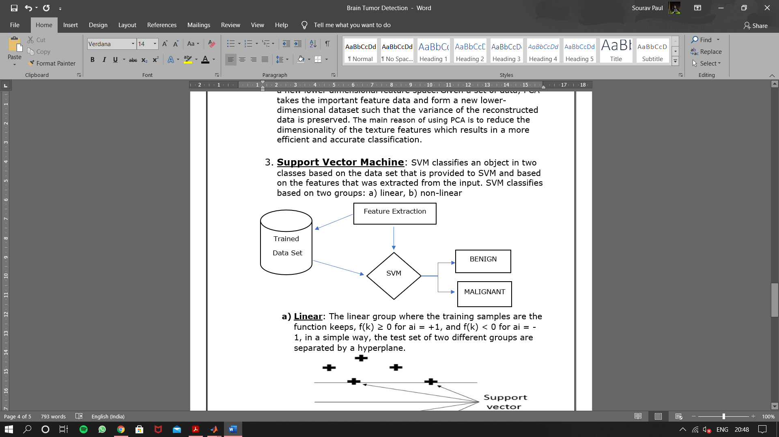

#### **Linear**: The linear group where the training samples are the function keeps, f(k) ≥ 0 for ai = +1, and f(k) < 0 for ai = -1, in a simple way, the test set of two different groups are separated by a hyperplane.

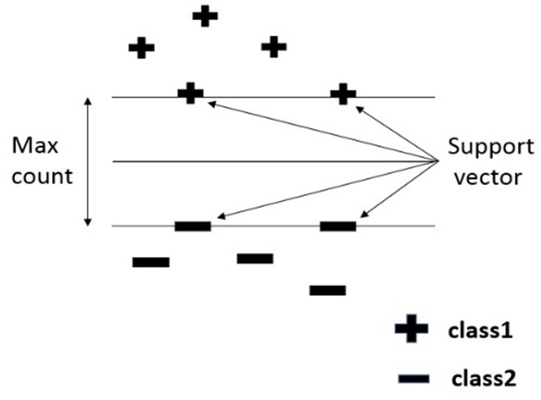

#### **Non-Linear**: When the training data are at different location then linear classification cannot be used. To overcome this non-linear classification used such that different kernels are analysed. It will take the input and map into higher space it will distinguish between two hyperplanes resulting into the prevention of data converging to the margin.

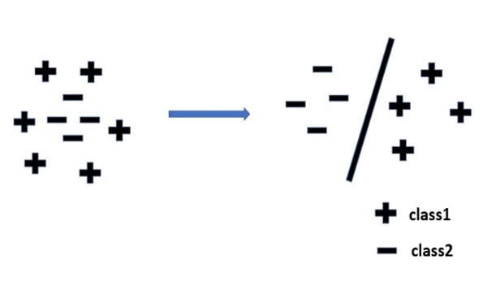

* **GUI Design**: The GUI was built using GUIDE, an inbuilt tool of MATLAB. In the guid there are two button one for selecting image and another for detecting tumor and a text field to display the type of tumor and three image field one for displaying original image one for tumor alone and one for marked tumor.
* **SIMULATION & RESULTS**:
* **GUI**: GUI was built and designed using MATLAB tool GUIDE. For testing the GUI a device of i3 7th gen processor with 6gb ram was

used. Total size of the GUI is 627mb (including MATLAB dependencies).

Details of the GUI is shown in below figures:

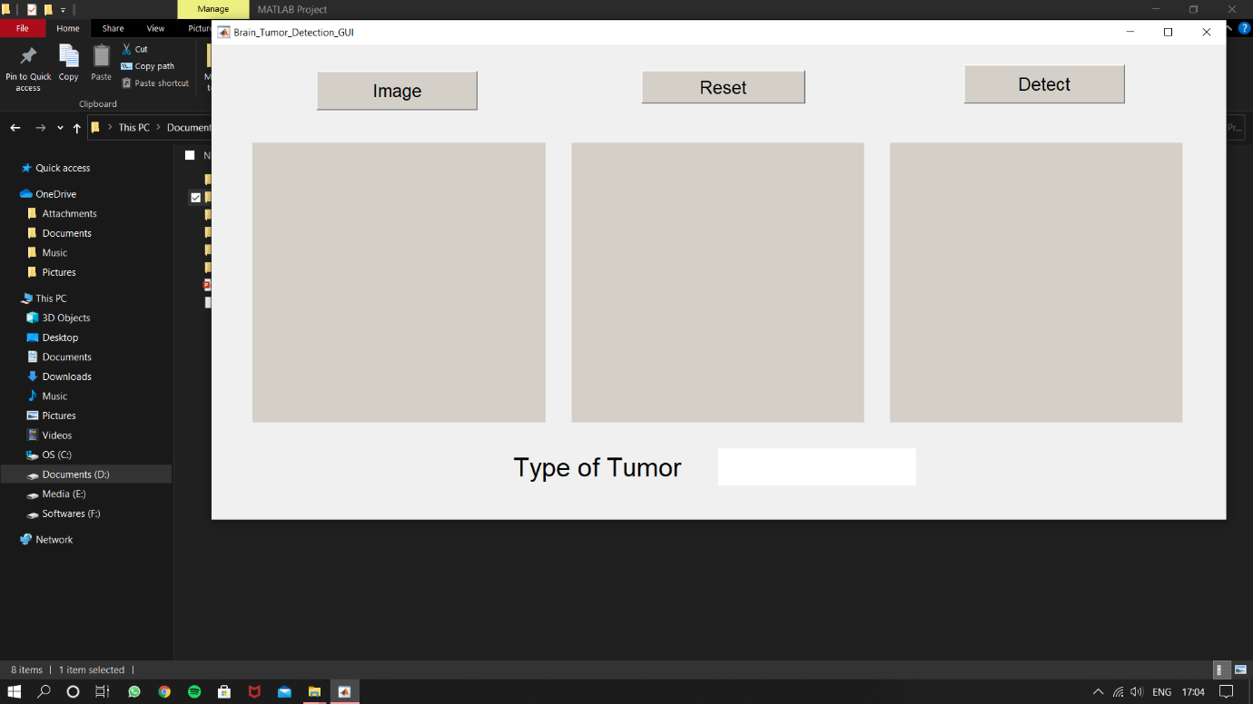

(a)

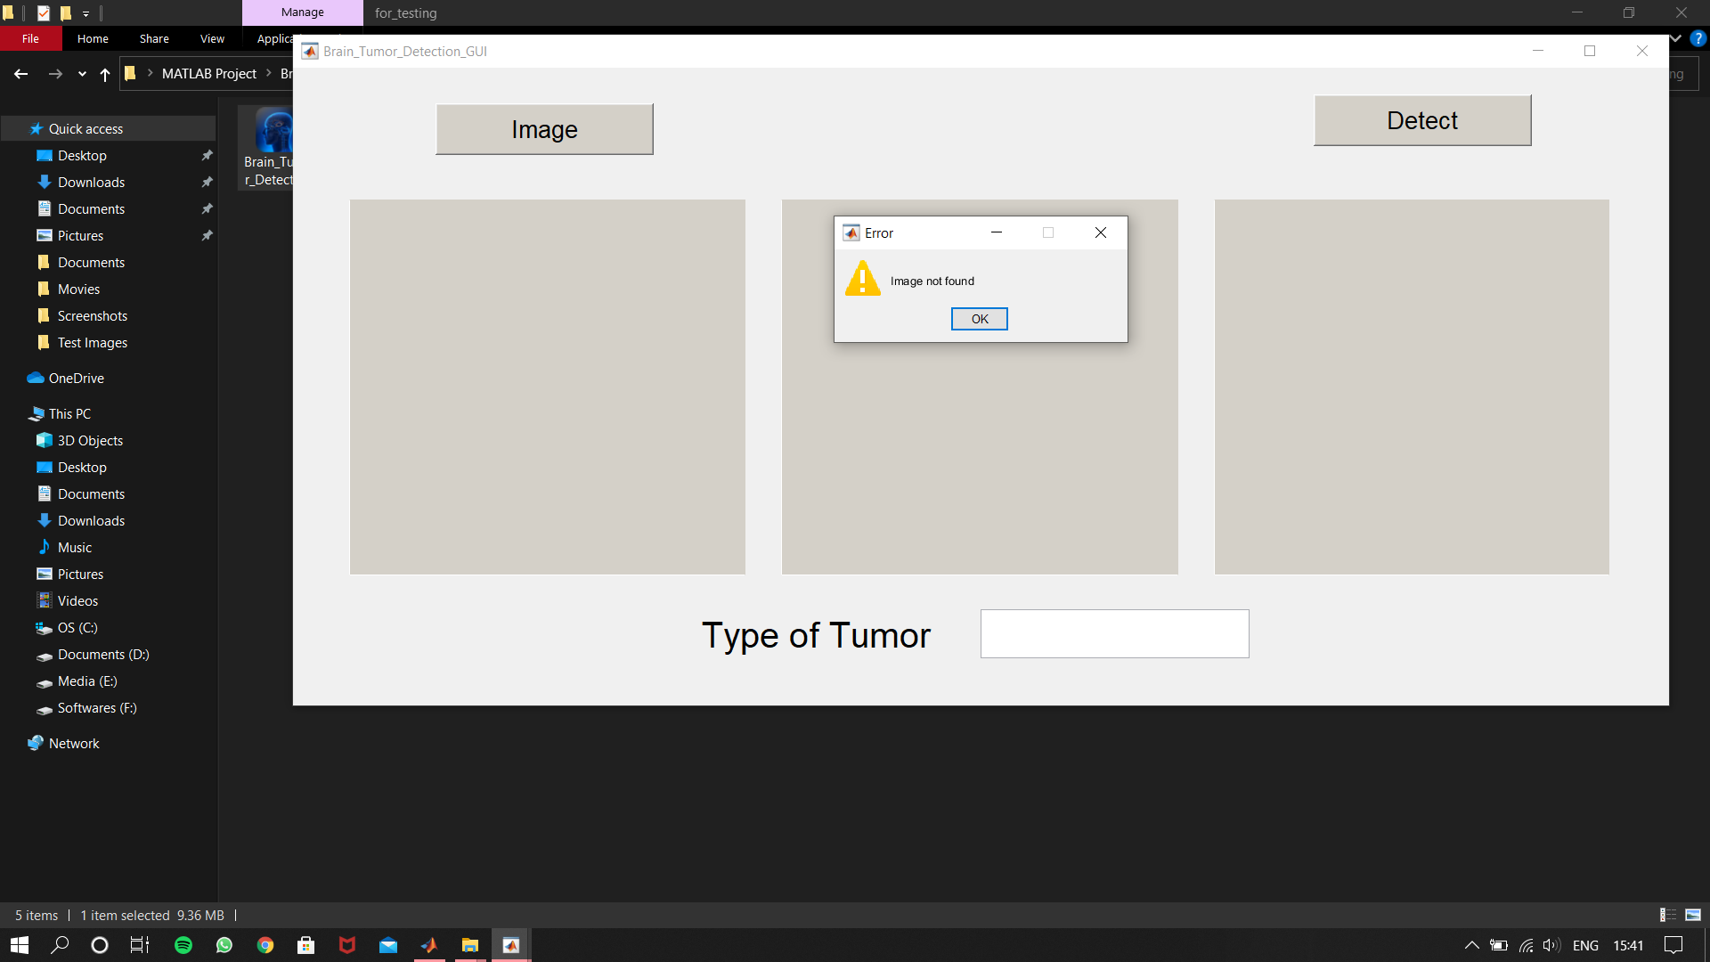

(b)

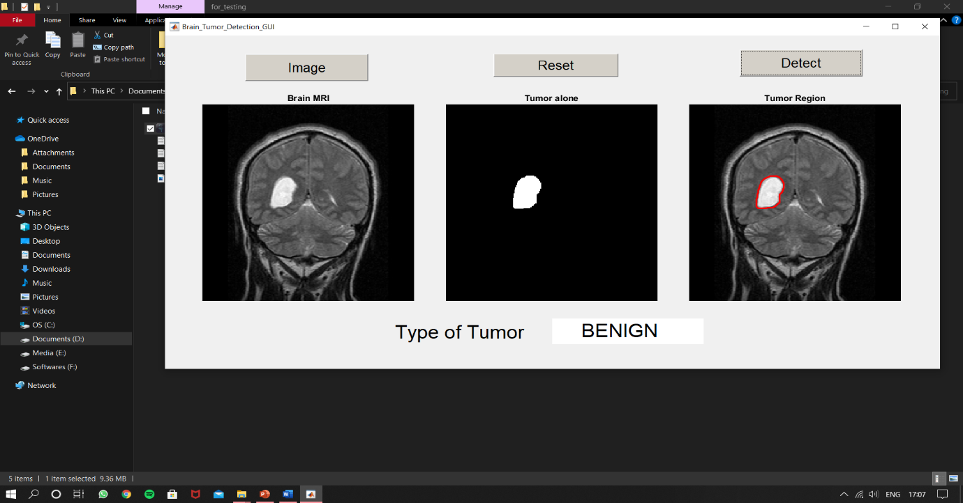

(c)

Figures: (a) Interface of the GUI; (b) Error screen in case user does not select any image; (c) Successful detection and classification output.

* **Internal Process Outputs**: There are many steps in this operation and every operation has its own output. All the outputs are shown in given figures:

|  |  |  |  |  |
| --- | --- | --- | --- | --- |
| **Original Image** | **Reduced Noise** | **Binary Image** | **Tumor Region** | **Marked Tumor** |
|  |  |  |  |  |
|  |  |  |  |  |
|  |  |  |  |  |
|  |  |  |  |  |
|  |  |  |  |  |

* **Experimental Results**: To check the performance of the algorithm, total 40 images were tested of benign and malignant type. Results are given below:

|  |  |  |  |  |  |
| --- | --- | --- | --- | --- | --- |
| **Class** | **Total Number of images** | **Total number of images**  **of that Class** | **True Detection** | **False Detection** | **Accuracy**  **(%)** |
| Benign | 40 | 21 | 19 | 2 | 90.5 |
| Malignant | 40 | 19 | 18 | 1 | 94.7 |

**Actual Accuracy**: 92.6%.

# **CONCLUSION**:

Cancer is probably the most widespread disease in the world. Braintumour is just a type of cancer that leads to the abnormal growth of brain tissues. This follows by nausea, intense headache, puking, blurry vision etc.

Here in the above project we have tried to abate the detection of brain tumours with the help of **image processing** feature in **MATLAB**. This makes it very easy for a user to detect the brain tumour and find the proper cure for it with just the use of a CTscanimage. And as it can be installed in any mobile devices so that improves its uses significantly further.

# **References**:

* 1) Design of Cellular Neural Network from Journal of Medical Imaging and Health Informatics vol- 2,1-11,2021 by Azian Azamini Abdullah,Zulkarnay Zakaria of Biomedical Electronics Engineering Programme, School of Mechatronic Engineering, University of Malaysia Perlis,02600 Ulu Pauh,Arau,Perlish,Malaysia.
* 2) Detection and Segmentation using Thresholding and Bounding Box from International Journal of Computer Application (097-8887) Vol-173-No.5, September 2017 by Chaitra G. and Sarika Tale of Department of DECS VTU-CPGS, VIAT Chickballapur-562101,India.
* 3) Image Extraction and segmentation from International Journal of Elecetronics,Communication & Computing Science and Engineering ISSN:2277-9477,Vol 2,Issue1 by Rajesh C. Patil, Dr. A.S.Bhalchandra.
* 4) Aaron, L., C. Joshua and W. Ross, 2003. Interactive GPU-Based level sets for 3D brain tumor segmentation. University of Utah, School of Computing, Technical Report UUCS-03-004, April 16.
* 5)Tumor Classification from MRI and SVM classififcation from Research Journal of Allied Sciences, Engineering and Technology 6(12):2264-2269,2013 by A. Jayachandra of Department of CSE,PSN College of Engineering and Technology, Tirunelveli, India and R.Dhanasekaram of Sayed Ammal Engineering College, Ramanathapuram, Tamilnadu, India.
* 6)Image Analysis based on SVM by Nilesh Bhaskarrao Bahadure and Arun Kumar Ray.
* 7)Masking and Noise Reduction and Trainset from Mathworks.com.
* 8)Histogram Based Segmentation by Chinnu A of Department of Computer Science and Engineering Sarabhai Institute of Science and Technology Vellanad, Trivandrum, India.

# **Acknowledgment**:

We would sincerely like to express thanks and gratitude our mentor “***Miss Roshni Chakraborty***”, and our HOD “***Mr. Sanjib Kumar Dhara***”, for providing us the golden opportunity to do this wonderful project on Brain Tumor Detection from MRI. Which also helped us to do a lot of research and further enhance our knowledge.

We would also like to extend our gratitude to our Principal

“***Dr. Maloy Kumar Chandra***”, who allowed us to do this wonderful project.

We also hugely thank all the group members for their contribution and cooperation for making this project a success. Without them this would not be possible in the limited time.

We whole heartily thank to all of the people who contributed to make this project a successful one.

**Sourav Paul**

**Sourav Roy**

**Anushka Dey**

**Surya Das**